HTML-5 Project Documentation:
Name:- Daya Shishir Trivedi
Course: Front-end development

Project Title: Digital Customer Interaction System
Target Organization: Hashcrypt Technologies Pvt. Ltd.
Document Type: Technical Project Synopsis & System Documentation
Development Paradigm: Incremental Lifecycle Model

Agenda
- Transition manual, paper-based records into a fast, paperless system.
- Provide a responsive user interface using fluid layout concepts.
- Implement strict client-side verification and data persistent operations.
Purpose
The primary purpose is to digitize customer interactions at Hashcrypt Technologies Pvt. Ltd.
This portal replaces paper workflows, accelerates response times, prevents data errors, and secures records in a local browser database.
Scope
- In-Scope: HTML5 semantic structure, Bootstrap 5 UI framework layout, external CSS customization, custom Java script evaluation, and localStorage storage management.
- Out-of-Scope: Advanced backend architectures, external cloud database configurations, and multi-factor authorization systems.

3. Technologies, Tools, & Platforms
Front-End Architecture
- Markup Language: HTML5 (pp. 1-2)
- Styling Engine: CSS3 & Bootstrap v5.3.2 UI framework (p. 1)
- Scripting Language: Vanilla ECMAScript 6+ (JavaScript) (p. 1)
Developer Environment
- IDE / Editor: Visual Studio Code / Cursor Editor
- Testing Platforms: Google Chrome DevTools, Mozilla Firefox
- Version Control: Git & GitHub Distributed Repository
Operating System Ecosystem
- Development Platform: Windows 11 Professional / macOS Sequoia
- Target Ecosystem: Cross-platform web browsers (Chrome, Safari, Edge, Firefox)

4. Objectives, Tasks, & Operational Constraints
Project Objectives
- Build a single-page responsive web layout with a fluid grid structure.
- Enforce instant feedback mechanisms near fields when data input rules fail.
- Persist structured complaint logs inside browser storage without data loss.
Project Tasks
- Task 1: Structure layout sections: Header, Navbar, Hero Slider, Form, and Results Table.
- Task 2: Apply Bootstrap classes to enable auto-collapsing layouts for mobile views.
- Task 3: Write JavaScript validation code for email formats and 10-digit phone values.
- Task 4: Create functions to read, parse, escape, and append data records into tables.
Constraints
- Storage Boundaries: Dependent on browser-managed storage space limitations (~5MB limit).
- Security Scope: Front-end data escaping prevents basic XSS vectors, but lacks server verification mechanisms.
- Environment Limits: Data is stored locally and will be cleared if the browser cache is wiped.

5. Hardware & Software Requirements
Hardware Specifications
- Processor: Intel Core i3 / AMD Ryzen 3 or higher
- Memory Architecture: Minimum 4 GB RAM
- Storage Capacity: 500 MB of available hard drive space
Software Environment
- Code Compilation: Any standard text editor or IDE
- Runtime Environment: Modern web browser with JavaScript enabled

6. Problem Solving & Process Model
Problem Statement
Manual processing slows down workflows, creates storage bottlenecks, and leads to validation errors during entry (p. 1). Missing records and slow lookups make it difficult to resolve client issues quickly.

Here is an objective critical analysis detailing the advantages and disadvantages of the compiled HTML5 project documentation, synopsis architectures, and system design specifications.

7. HTML-5 Project Advantages
High Structural Readability
- Clear Section Organization: The documentation uses standard software engineering frameworks. It includes separate sections for requirements, diagrams, data dictionaries, and architectural scope.
- Clear Sizing: It uses clean markdown formatting tables, bold text cues, and structured bullet lists. This makes it easy for project guides, engineers, and clients to scan.
Thorough Technical Specifications
- Complete System Requirements: It explicitly details hardware requirements, development operating systems, front-end libraries, and version tools. This ensures repeatable setups across different developer environments.
- Isolated Scope Boundaries: Defining boundaries helps prevent "scope creep" by specifying exactly what features are included and what features are excluded (such as external databases or back-end authorization frameworks).
Complete Diagram Blueprint Portfolio
- Diverse UML Dimensions: It provides a comprehensive set of engineering diagrams, including DFDs, ER diagrams, activity diagrams, sequence charts, and real-world functional swim lane flowcharts.
- Production-Ready Formats: Providing these models as text-editable Mermaid scripts allows teams to version-control, update, or re-render diagrams instantly without needing separate graphical design files.
Data Integrity Definition
- Explicit Data Dictionaries: Identifying variable storage keys, target element selectors, data types, and sanitization validation rules simplifies debugging and maintenance tasks for future developers.

8. HTML-5 Project Disadvantages
Scope Limitations (Frontend Focus)
- Lack of Backend Architecture: Because the project focuses entirely on a frontend-only architecture, the documentation lacks details on cloud server operations, API endpoint designs, and structural server data routing patterns.
- Missing Performance Metrics: The synopsis does not define non-functional performance benchmarks, such as page load speed goals, input processing times, or file size limits.
Local Storage Security Constraints
- Limited Security Parameters: The documentation mentions front-end text character sanitization to prevent basic XSS vulnerabilities. However, it lacks advanced security policies, data encryption standards, or secure user authorization setups.
- Data Vulnerability: The data dictionary focuses entirely on browser-managed storage (window.localStorage). This means the system is vulnerable to data loss if a user clears their browser cache or uses private browsing windows.
Missing Test and Maintenance Vectors
- No Test Verification Matrix: The documentation does not include a dedicated Quality Assurance section with structural unit tests, automated test inputs, or explicit pass/fail evaluation rules.
- Lack of Deployment Workflows: The synopsis covers development tools but leaves out production deployment steps, build tools, performance tuning rules, and CDN configuration guidelines.

8.Screenshots:
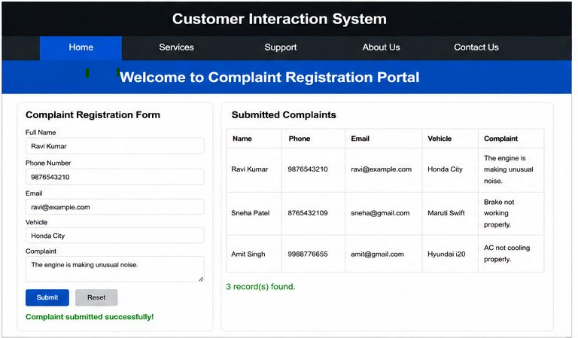

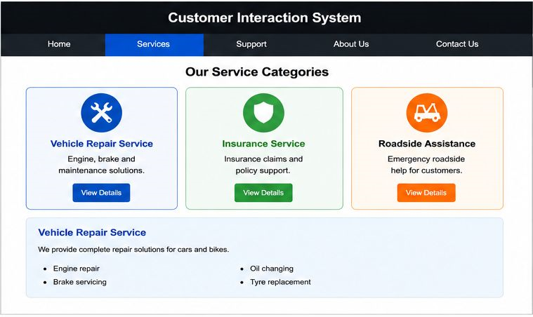

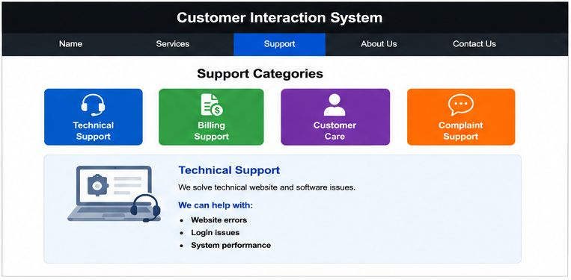

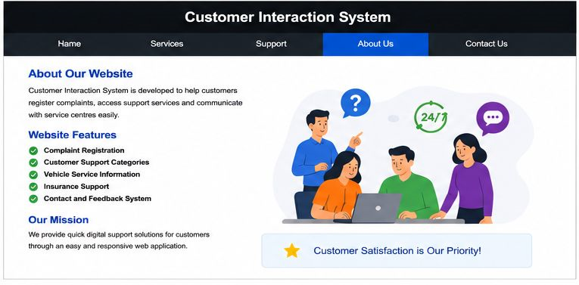

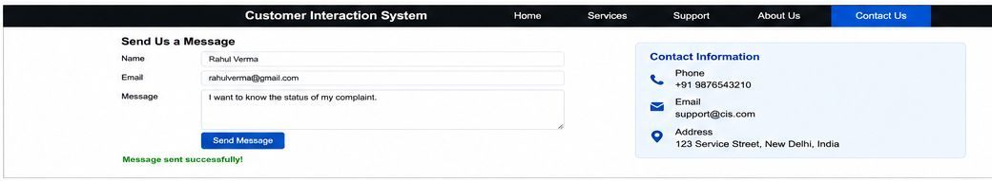

9. Incremental Model Application
The system was designed using an Incremental Model, breaking development into distinct, functional blocks:
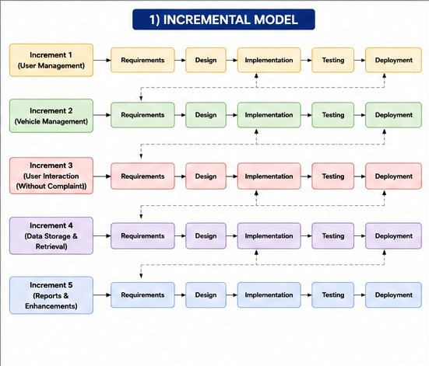
10.Data Flow Diagram:-
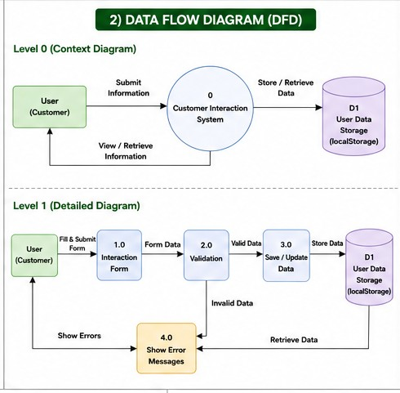
11.E-R Diagram
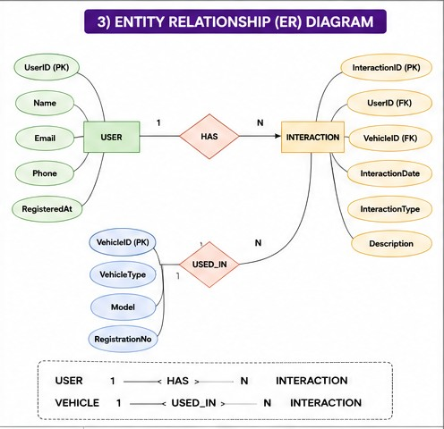
12.Use Case Diagram
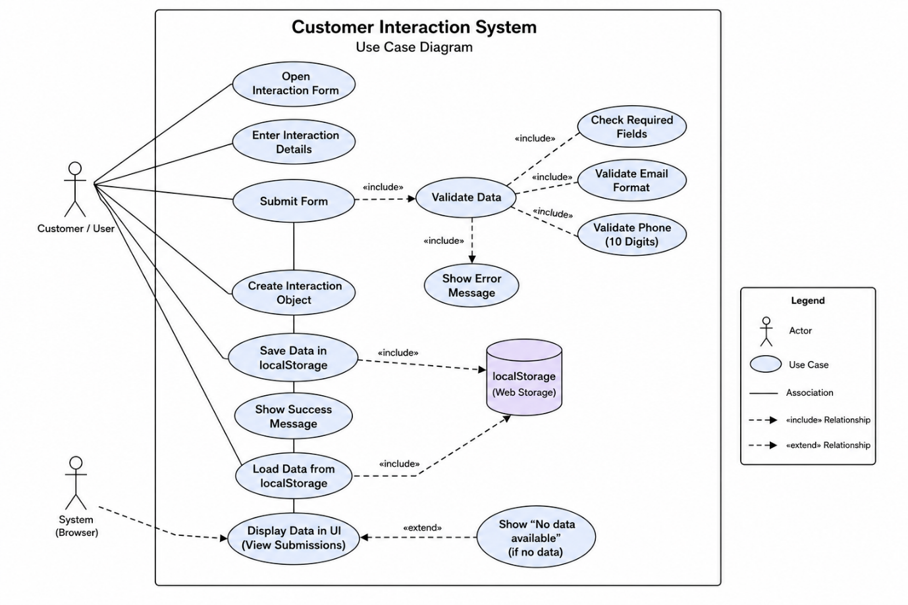

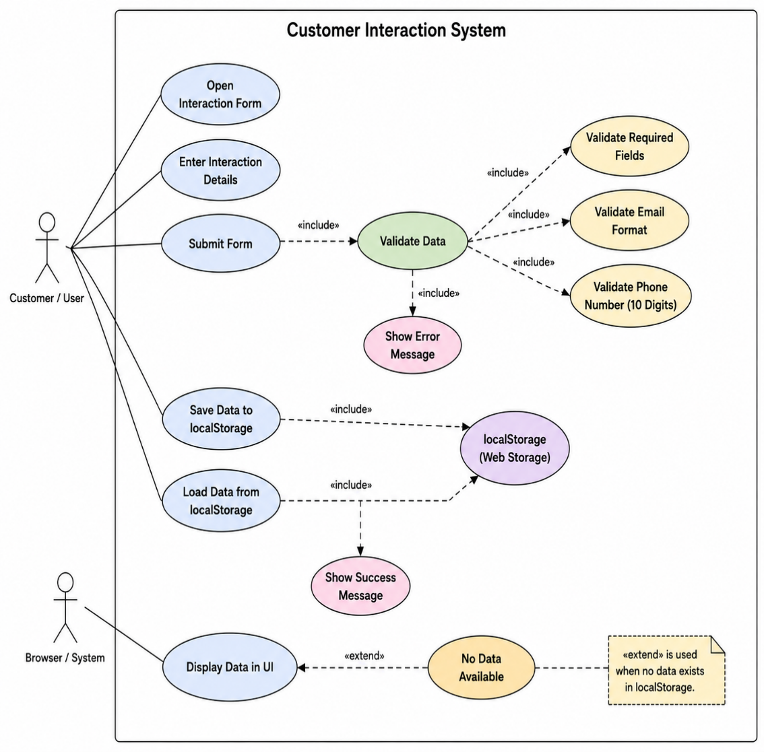
13.Activity Diagram
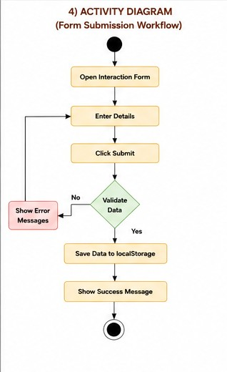

14.Sequence Diagram
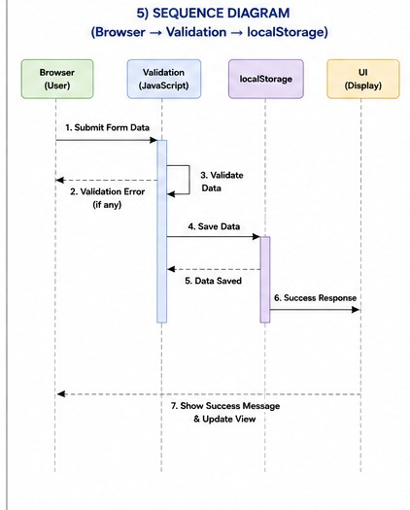
15.Flowchart:
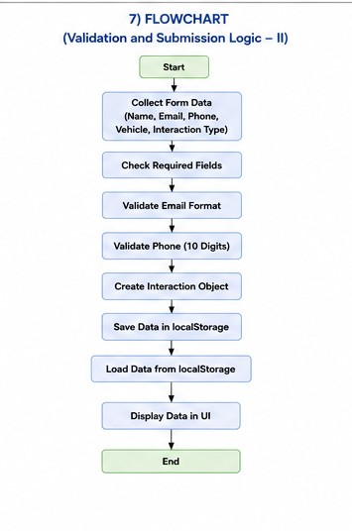

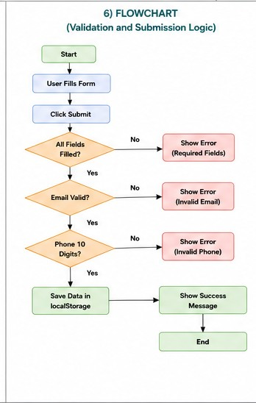

16. Data Dictionaries
The system manages records as a collection of JavaScript objects serialized within the browser storage environment :
Key Identifier | Data Type | Field Rules / Constraints | Functional Purpose
Name | String | Required, alphanumeric text format | Stores the customer's full name
Phone | String / Numeric | Required, exactly 10 digits long | Stores the verified contact number
Email | String | Required, matching user@domain.com patterns | Stores the customer's communication address
Vehicle | String | Required, non-empty text string | Stores the specific vehicle model details
complaint | String | Required, non-empty text description | Stores the logs describing the system issues

17. System Characteristics & Implementation Features
- Fluid Responsive Layout: Uses Bootstrap's grid architecture to auto-collapse columns into vertically stacked view segments on smaller mobile screens.
- Input Sanitization: Uses a custom mapping module to filter specific operational syntax symbols, preventing cross-site scripting vulnerabilities.
- Real-time Interface Rendering: Updates UI elements instantaneously by reading, transforming, and appending database states without requiring a full browser page refresh.

18. Conclusions & Discussions
The digital Customer Interaction System meets all development goals for Hashcrypt Technologies Pvt. Ltd. Moving to a digital portal speeds up customer ticket routing and replaces slow, paper-based tracking methods .
Future development updates can improve functionality by shifting the application from local browser storage to an online SQL or NoSQL database. This change will allow for multi-user synchronization, role-based login portals, and deep-dive analytical reporting features .

